Abstract samples

DEGRADATION OF LIPID REGULATORS AND TRITON X-100 NONIONIC DETERGENT BY IONIZING RADIATION

G. Rácz, T. Csay, E. Takács, L. Wojnárovits
Institute for Energy Security and Environmental Safety, Centre for Energy Research, Hungarian Academy of Sciences, Budapest, Hungary

In this work the radiation induced decomposition of Triton X-100 (TX-100), nonionic detergent was studied alone and in combination with fibrate type lipid regulators. Lipid regulators are usually hydrophobic compounds with very low solubility in water. Detergents are always present in municipal wastewater improving the solubility of solutes in water. This practical situation was simulated by adding nonioinic detergent to the fibrate solution. The detergent improved the water solubility of the lipid regulator, therefore, we had an opportunity to study the degradation of the moderately water soluble clofibric acid (CFA) in a nonmicellar system. Co-60 gamma source was applied to produce the reactive intermediates (•OH, H• and e_{aq}–). The degradation was followed with UV-visible spectrophotometer. LC-MS/MS and GC-MS were applied for the separation and identification of the degradation products. The degree of the mineralisation, oxidation and acidity of the solution was characterized with chemical oxygen demand, total organic carbon and pH measurements, respectively. The shift of critical micelle concentration (CMC) with absorbed dose was observed with tensiometric measurements (Figure 1). Based on the results obtained by these methods degradation pathways for TX-100 and CFA were suggested. In the presence of detergent the efficiency of the decomposition of the fibrate was much lower than without detergent, although, even this case a considerable degradation was observed. It is assumed that the efficiency of degradation in the reaction of hydroxyl radical and fibrates is higher than that of the reaction between OH radical and TX-100.
Figure 1. Surface tension values measured in irradiated TX-100 solutions. The table shows the change in CMC values with the dose.

ENHANCING THE BIOLOGICAL DEGRADABILITY OF SULFAMETHOXAZOLE BY IONIZING RADIATION TREATMENT IN AQUEOUS SOLUTION

Gy. Sági¹, K. Kovács¹, A. Bezsenyi², T. Csay¹, E. Takács¹, L. Wojnárovits¹
¹Institute for Energy Security and Environmental Safety, Centre for Energy Research, Hungarian Academy of Sciences, Budapest, Hungary
²South-Pest Wastewater Treatment Plant, Budapest, Hungary

Removal efficiency of persistent organic substances in wastewater is mostly described by the rate of degradation. In numerous studies complete removal of target molecules have been reported, indicating a reasonable alternative for the waste treatment. However, these studies often ignore considerations of the inevitable questions of toxicity and biodegradability of the resulting solutions. Although the high removal rate is very important, but it does not necessarily have to be privileged, since minor alteration of the chemical structure may lead to considerable quality changes that improve the degradation efficiency by conventional technologies. It has been shown that the treatment of persistent organic pollutants by ionizing radiation leads to changes in chemical structure even at very low doses. Nevertheless, very little is known about the biological effects of the treated solutions.
Preparatory to recent study, degradation of sulfonamide antibiotics during ionizing radiation treatment was examined and general degradation mechanism was proposed after applying a large variety of analytical techniques in order to characterize the different stages of decomposition.^{[1,2]} In the knowledge of the chemical background, this presentation aims to introduce results obtained on sulfamethoxazole irradiation treatment in the 0-10 kGy range, in terms of crucial parameters mentioned in previous paragraph. Biological degradability and inhibitory effects were both investigated using municipal activated sludge. The biodegradability in 0.1 mmol dm⁻³ solutions was increased with only 0.4 kGy and prolonged irradiation induced further conversion to biologically treatable substances. At 2.5 kGy, 16% of the chemically oxidizable organic matter was degraded by biological processes. The total organic carbon content showed a decrease of only 15% at this point, thus high degree of mineralization is not necessary to make the initial molecule available for microorganisms. During the process, formation of H₂O₂ was observed that may decisively influence the biological processes due to its bactericidal effect.

[1] Gy. Sági et al., J. Radioanal. Nucl. Chem., 2014, 301, 475.
[2] Gy. Sági et al., J. Pharm. Biomed. Anal., 2015, 106, 52.

PENICILLINS IN THE FACET OF RADIATION CHEMISTRY

L. Szabó^{1,2}, T. Tóth², G. Rácz¹, T. Engelhardt³, Cs. Mohácsi-Farkas³, E. Takács¹,
L. Wojnárovits¹
¹Institute for Energy Security and Environmental Safety, Centre for Energy Research, Hungarian Academy of Sciences, Budapest, Hungary
²Department of Organic Chemistry and Technology, Budapest University of Technology and Economics, Budapest, Hungary
³Department of Microbiology and Biotechnology, Corvinus University of Budapest, Budapest, Hungary

There are two principally different issues that prompt to study the reactions of penicillins with water radiolysis intermediates. One concerns the applicability of radiation processing for the elimination of antibiotic residues that is omnipresent in wastewater matrices and facilitates the spread of antibiotic resistance involving also pathogenic bacterial species. From this point of view, one needs to focus on the reactions ultimately leading to the destruction of the pharmacophore of the penicillin (the β-lactam ring) that determines the antimicrobial activity. Evaluating the kinetics of the reactions of •OH and e_{aq}⁻ with these antibiotics and determining the stoichiometry of the antimicrobial deactivation to achieve an effective rate constant is of special interest for implementation of the technique. On the other hand, the effects of the products on bacterial species also have to be probed to ensure the elimination of any selective pressure and prove the reliability of the process. Another issue aids to understand in vivo processes since these antibiotics target mitochondrial components generating oxidative stress and thereby reactive oxygen species. Establishing one electron oxidation/reduction mechanisms and identifying reactive intermediates are therein the main subjects.
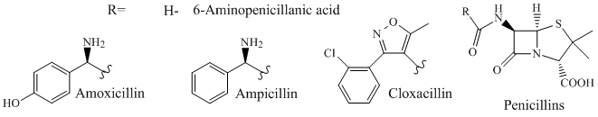
Figure 1.Investigated compounds.

Widely used derivatives were chosen as model compounds: amoxicillin, ampicillin, cloxacillin and their common 6-aminopenicillanic acid nucleus. Pulse radiolysis technique was utilized to shed light on the kinetics and mechanism of the early processes, whereas final product analysis and bacterial bioassays were carried out after steady-state gamma-irradiation. The pharmacophore was tracked by using UV/Vis and IR spectroscopic methods. This presentation will attempt to give a picture of the above issues by introducing recent results.

HYDROXYL RADICAL REACTIONS WITH MONURON

V. Mile¹, I. Harsányi¹, K. Kovács¹, T. Földes², I. Pápai², E. Takács¹, L. Wojnárovits¹
¹ Institute for Energy Security and Environmental Safety, Centre for Energy Research, Hungarian Academy of Sciences, Budapest, Hungary
² Institute of Organic Chemistry, Research Centre for Natural Sciences, Hungarian Academy of Sciences, Budapest, Hungary

In Advanced Oxidation Processes hydroxyl radicals are the reactive intermediates which induce the decomposition of toxic organic compounds present in water matrices. Previously, the degradation of monuron (3-(4-chlorophenyl)-1,1-dimethylurea) in dilute aqueous solution (1×10⁻⁴ mol/dm³) was studied in our laboratory. Based on the experimental results, the main process is the reaction between monuron and ●OH forming hydroxycyclohexadienyl radical.
The present work focuses on the aromatic ring hydroxylation using quantum chemical calculations. The addition of hydroxyl radical to the aromatic ring can take place at different positions. The different possible reaction pathways were studied by means of Density Functional Theory (DFT). All geometrical optimizations were carried out using the DFT/B3LYP/6-311++G(d,p) methodology in aqueous medium applying the Solvation Model Density (SMD). The electronic energy was refined by single-point energy calculations at the B3LYP/6-311++G(3df,3pd) level.
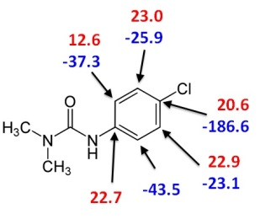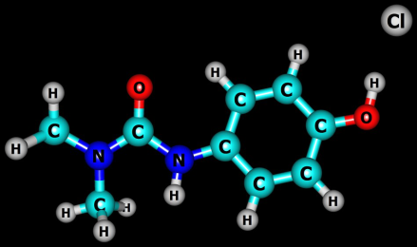
Figure 1. Activation energies and Gibbs free energies of the reactions in kJ/mol (left) and product of the para addition reaction which shows loss of a chlorine (right).

The para addition path is an energetically favourable reaction with loss of a chlorine. The Cl elimination is in good agreement with the results of chemical analysis. The bond length of C_{ring}….O_{radical} is 1.32 Å for the para addition product. In case of ipso-, ortho- and meta-hydroxycyclohexadienyl radical the C_{ring}….O_{radical} distances are about 1.46 Å. The C_{ring}….O_{radical} distance of the transition states vary between 2.03 and 2.15 Å except for ortho2 transition state. In this case no transition state was found using the aqueous continuum solvation model. Without applying SMD (e.g. in vacuum) the C_{ring}….O_{radical} distance of the transition state of ortho2-additon is 2.19 Å.

